1.SUM OF ALL ARRAY ELEMENTS

#include<stdio.h>

int main()

{

int a[5], i, sum=0;

printf("Enter the array Elements\n");

for(i=0;i<5;i++)

scanf("%d",&a[i]);

for(i=0;i<5;i++)

sum=sum +a[i];

printf("Sum of all array Elements = %d",sum);

return 0;

}

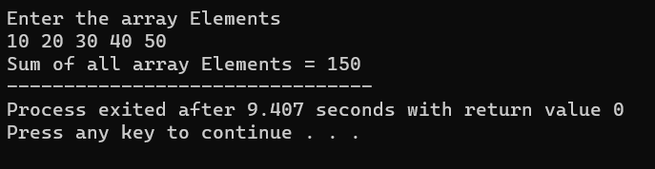

2.SUM OF TWO MATRIX

#include<stdio.h>

int main()

{

int a[100][100],b[100][100],c[100][100],m,n,i,j;

printf("Enter the number of rows :");

scanf("%d",&m);

printf("Enter the number of columns :");

scanf("%d",&n);

printf("Enter the Elements of Matrix 1 : \n");

for(i=0;i<m;i++)

{

for(j=0;j<n;j++)

{

scanf("%d",&a[i][j]);

}

}

printf("Enter the Elements of Matrix 2 : \n");

for(i=0;i<m;i++)

{

for(j=0;j<n;j++)

{

scanf("%d",&b[i][j]);

}

}

for(i=0;i<m;i++)

{

for(j=0;j<n;j++)

{

c[i][j]=a[i][j]+b[i][j];

}

}

printf("Sum of Two Matrix : \n");

for(i=0;i<m;i++)

{

for(j=0;j<n;j++)

{

printf("%d\t",c[i][j]); {

if (j == n - 1)

printf("\n\n");

}

}

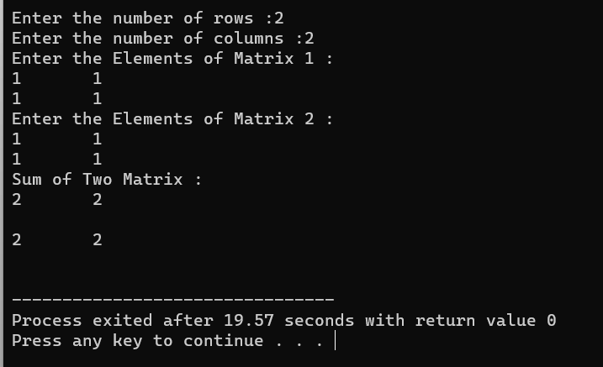 }

return 0;

}

3.LARGEST OF ARRAY ELEMENTS

#include<stdio.h>

int main()

{

int a[5],large_no,i;

printf("Enter the Elements of an array : ");

for(i=0;i<5;i++)

{

scanf("%d",&a[i]);

}

large_no=a[i];

for(i=0;i<5;i++)

{

if(large_no<a[i])

{

large_no=a[i];

}

}

printf("Largest Element in an Array =%d",large_no);

return 0;

}

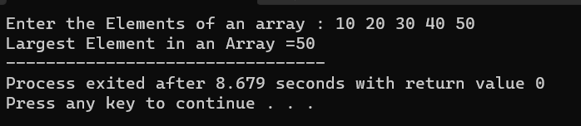

4.TOWERS OF HANOI

#include<stdio.h>

int count=0;

void toh(int,char,char,char);

int main()

{

int n;

printf("Enter the Disk : ");

scanf("%d",&n);

printf("Sequence is : \n");

toh(n,'s','t','d');

printf("\nThe number of moves %d",count);

return 0;

}

void toh(int no,char source,char temp,char dest)

{

if(no>0)

{

toh(no-1,source,temp,dest);

printf("Move disk %d %c=%c",no,source,dest);

count++;

toh(no-1,temp,source,dest);

}

}

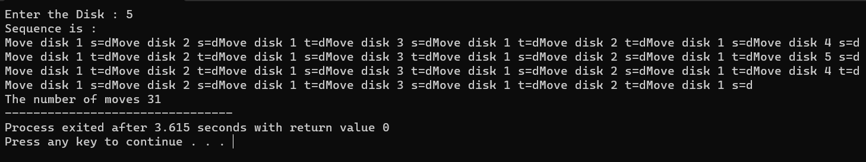

5.TIME TAKEN FOR EXECUTION

#include<stdio.h>

#include<time.h>

int main()

{

char c;

double duration;

clock_t start,end;

start = clock();

printf("Enter any Character : ");

c=getchar();

end = clock();

duration=(((double)end-start)/CLOCKS_PER_SEC);

printf("Character C =%C",c);

printf("Time taken to execute is = %f",duration);

return 0;

}

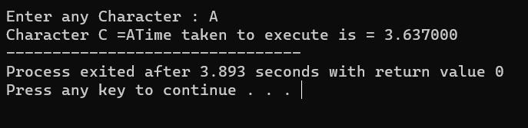

6.KNAPSACK 0/1

#include<stdio.h>

int i,n,C,w[50],p[50],maxprofit;

int maximum(int x,int y)

{

if(x>y)

return x;

else

return y;

}

knapsack(int i,int c)

{

if(i==n)

return((c<w[n])?0:p[n]);

if(c<w[i])

return knapsack(i+1,c);

return maximum(knapsack(i+1,c),knapsack(i+1,c-w[i])+p[i]);

}

int main()

{

printf("\nEnter the number of objects:\n");

scanf("%d",&n);

printf("\nEnter the weights:\n");

for(i=0;i<n;i++)

scanf("%d",&w[i]);

printf("\nEnter the profits:\n");

for(i=0;i<n;i++)

scanf("%d",&p[i]);

printf("\nEnter the capacity:\n");

scanf("%d",&C);

maxprofit=knapsack(0,C);

printf("\n Maximum profit = %d",maxprofit);

return 0;

}

